**Creating a Domain:**

To Create the compact domain (Standalone server) we require

a) Oracle DB needs to installed

b) Install RCU to create required schema’s

C:\OracleSOA12C\Middleware\Oracle_Home\oracle_common\bin>rcu.bat

* Double Click on the file.

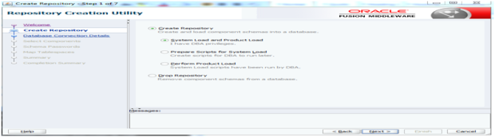

* Enter DB details.

Hostname: Localhost

Port : 1521

Service name: XE

Username : SYS

Password : DBA password

Then Click on next

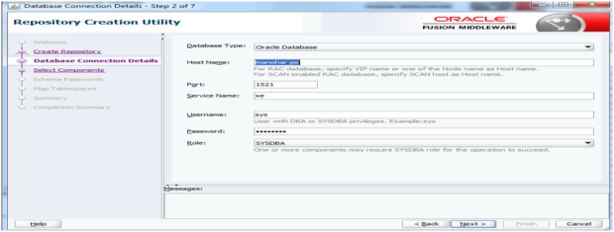

* Keep any profile name: DEV, PROD and click next

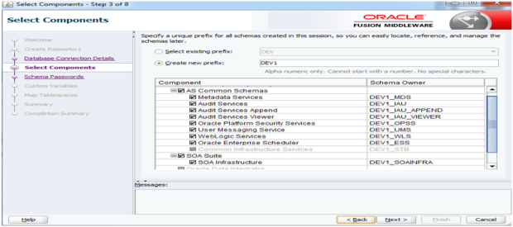

* Click ok after test is finished and the pop display as shown below.

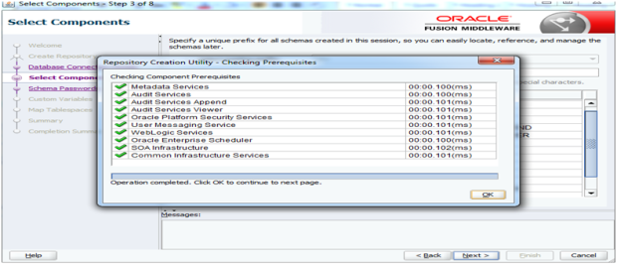

* Enter as Given in the DBA password.

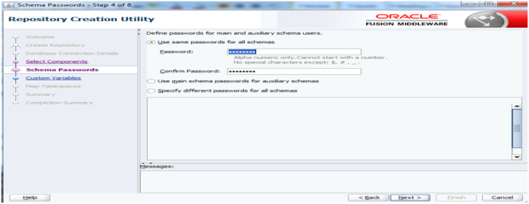

* Click on next.

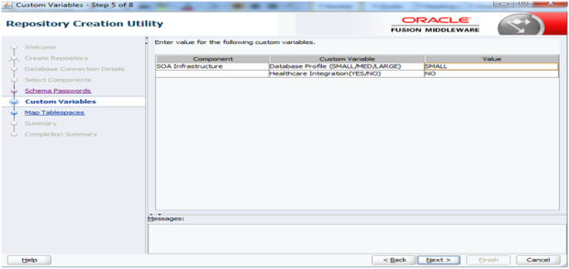

* Click on next.

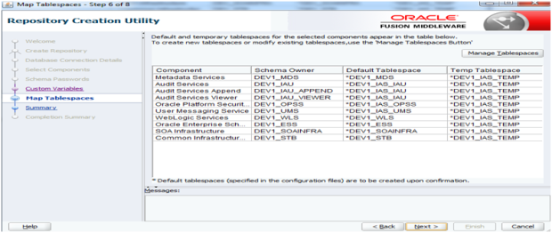

* Click ok.

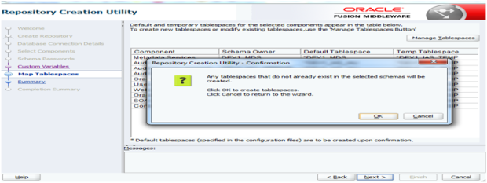

* Click on create.

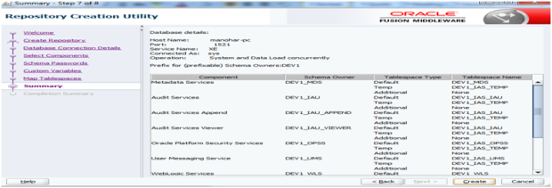

Open command prompt and run the below mentioned commands.

c) Create compact domain as below

cd ORACLE_HOME\oracle_common\common\bin

SET CONFIG_JVM_ARGS=-Dcom.oracle.cie.config.showProfile=true

**config.cmd**

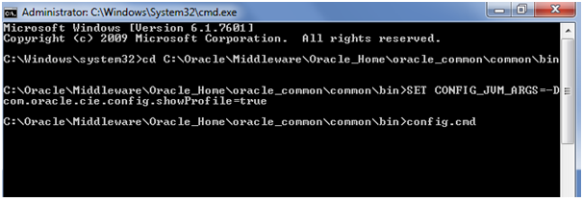

* Click on next

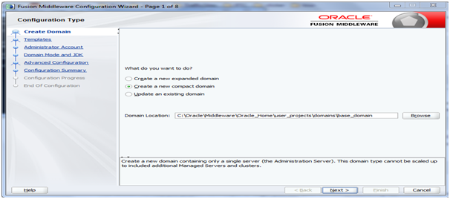

* Choose required template and click on next.

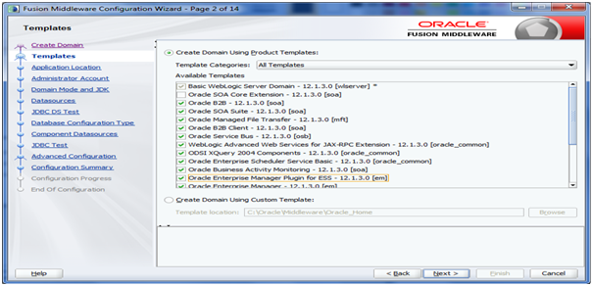

* Click on next.

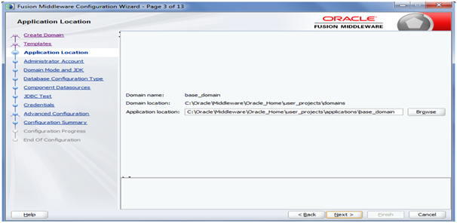

* Enter DB details as kept while creating RCU

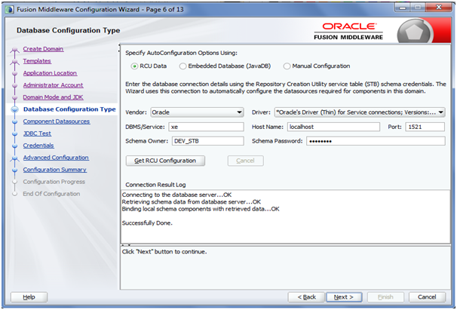

* Alter user DEV_STB identified by SapthaGiri123 account unlock;(If user not able to access)

IP: 10.77.28.64

* Then click on next

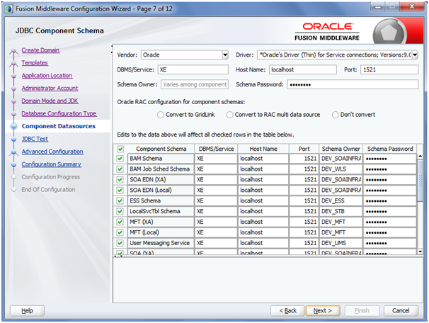

* Choose the setting required.

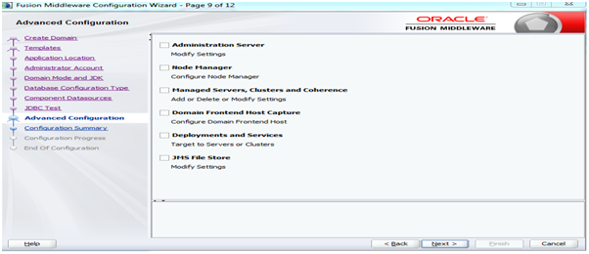

* Click next

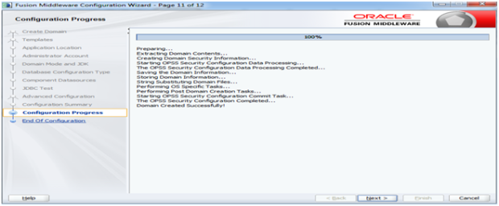

* Click on finish

